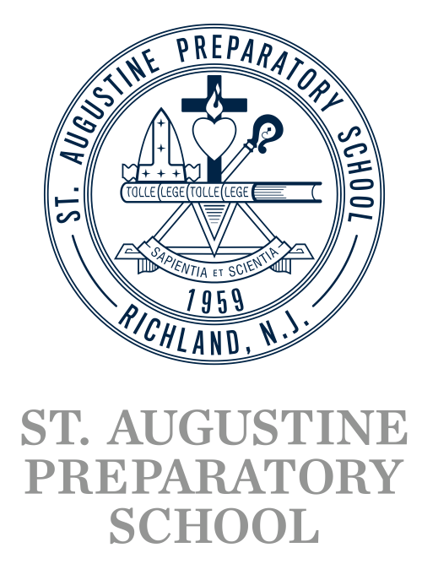

Dear Scholarship Committee,
In response to a scholarship made available through your organization, enclosed please find a completed application from a senior student enrolled at St. Augustine Preparatory School in Richland, New Jersey.
It is in the spirit of unity that we encourage our students to be community aware and involved in the many aspects of service and are grateful to those organizations that recognize these efforts in young, college-bound students. In the event a St. Augustine Prep student is selected as the recipient of your scholarship, I am requesting that our College Guidance department be notified, in addition to the student.
Feel free to contact our general office, 856-697-2600, Ext. 114., or complete and fax this form to 856-285-7117.
Sincerely,

Mrs. Carol Castelli
Director of College Guidance
(856) 697-2600, Ext. 148
St. Augustine Preparatory School
611 Cedar Avenue
Richland, New Jersey 08350

Name of Organization and phone number:

Student who applied:

Name of the Scholarship and Award Amount:

